1. Shortest Job First (Preemptive)

#include <stdio.h>

int main()

{

int arrival_time[10], burst_time[10], temp[10];

int i, smallest, count = 0, time, limit;

double wait_time = 0, turnaround_time = 0, end;

float average_waiting_time, average_turnaround_time;

printf("\nEnter the Total Number of Processes:\t");

scanf("%d", &limit);

printf("\nEnter Details of %d Processesn", limit);

for(i = 0; i < limit; i++)

{

printf("\nEnter Arrival Time:\t"); scanf("%d", &arrival_time[i]); printf("Enter Burst Time:\t"); scanf("%d", &burst_time[i]); temp[i] = burst_time[i];

}

burst_time[9] = 9999;

for(time = 0; count != limit; time++)

{

smallest = 9;

for(i = 0; i < limit; i++)

{

if(arrival_time[i] <= time && burst_time[i] < burs t_time[smallest] && burst_time[i] > 0)

{

smallest = i;

}

}

burst_time[smallest]--;

if(burst_time[smallest] == 0)

{

count++;

end = time + 1;

wait_time = wait_time + end - arrival_time[smallest]- temp[smallest];

turnaround_time = turnaround_time + end -

arrival_time[smallest];

}

e);

ime);

}

}

average_waiting_time = wait_time / limit; average_turnaround_time = turnaround_time / limit; printf("\n\nAverage Waiting Time:\t%lf\n", average_waiting_tim

printf("Average Turnaround Time:\t%lf\n", average_turnaround_t return 0;

**OUTPUT:-**

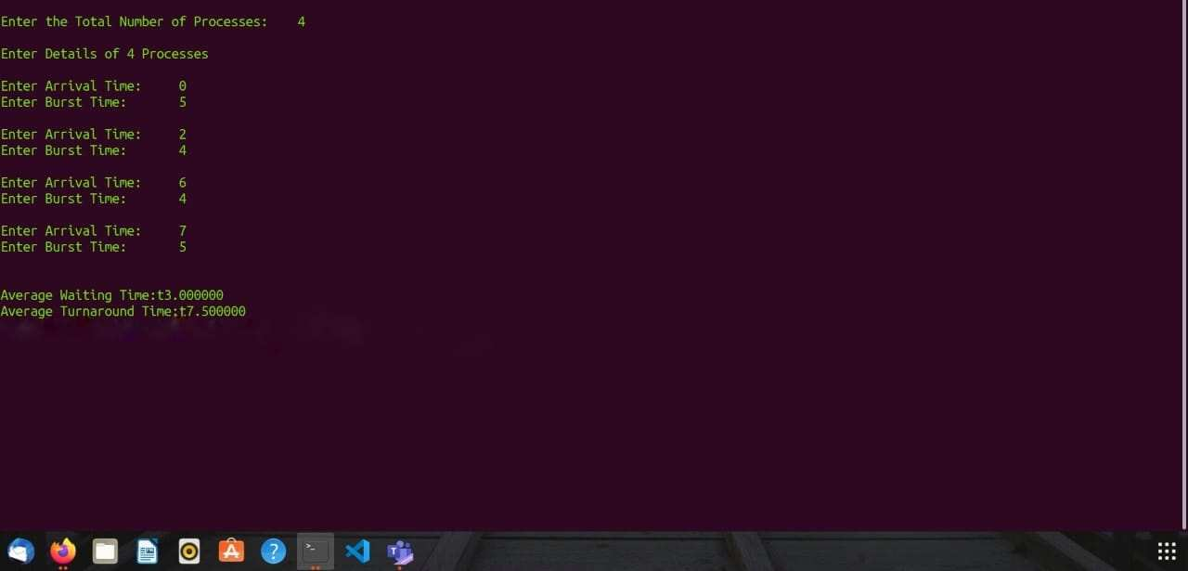

**2. Round Robin**

#include <stdio.h>

int main()

{

int i, total = 0, x, limit, counter = 0, t_quantum;

int wait_time = 0, turnaround_time = 0, arrival_time[10], burst_t ime[10], temp[10];

float average_wait_time, average_turnaround_time;

printf("\nEnter Total Number of Processes: ");

scanf("%d", &limit);

x = limit;

for (i = 0; i < limit; i++)

{

printf("\nProvide the details for Process[%d]\n", i + 1);

printf("Arrival Time:\t");

scanf("%d", &arrival_time[i]);

printf("Burst Time:\t"); scanf("%d", &burst_time[i]); temp[i] = burst_time[i];

}

printf("\nEnter Time Quantum:\t");

scanf("%d", &t_quantum);

printf("\nProcess ID\t\tBurst Time\t Turnaround Time\t Waiting Ti me\n");

for (total = 0, i = 0; x != 0;)

{

if (temp[i] <= t_quantum && temp[i] > 0)

{

total = total + temp[i];

temp[i] = 0;

counter = 1;

}

else if (temp[i] > 0)

{

temp[i] = temp[i] - t_quantum;

total = total + t_quantum;

}

if (temp[i] == 0 && counter == 1)

{

x--;

printf("\nProcess[%d]\t\t%d\t\t %d\t\t\t %d", i + 1, burst_

time[i], total - arrival_time[i], total - arrival_time[i] - burst_time[i]);

wait_time = wait_time + total - arrival_time[i] -

burst_time[i];

turnaround_time = turnaround_time + total - arrival_time[i];

counter = 0;

}

if (i == limit - 1)

{

i = 0;

}

else if (arrival_time[i + 1] <= total)

{

i++;

}

else

{

i = 0;

}

}

average_wait_time = wait_time *1.0 / limit;

average_turnaround_time = turnaround_time *1.0 / limit;

printf("\n\nAverage Waiting Time:\t%f", average_wait_time);

printf("\nAvg Turnaround Time:\t%f\n", average_turnaround_time);

return 0;

}

**OUTPUT:-**

